**Kubernetes Blue-Green Deployments**

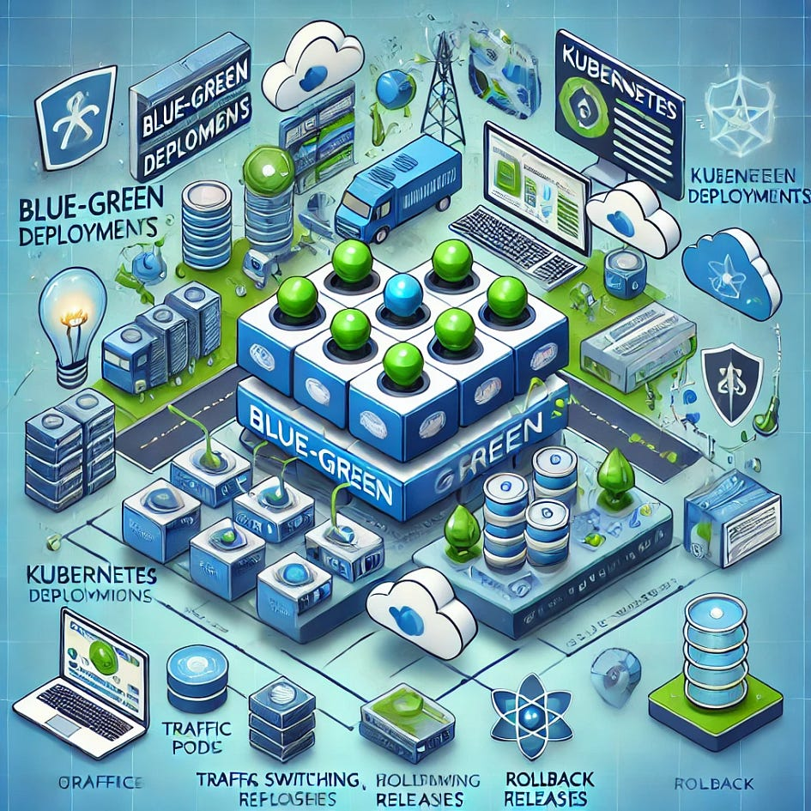

**🎯 Learning Objective:**

Understand how to perform blue-green deployments in Kubernetes to reduce downtime and risk during application updates.

**📖 Scenario:**

You need to update your application in a Kubernetes cluster with minimal downtime and risk by maintaining two identical environments, one for the current production version (blue) and one for the new version (green).

**📘 Explanation:**

Blue-green deployments involve maintaining two separate environments (blue and green) for your application. The blue environment serves the current production traffic, while the green environment is used to deploy the new version. After testing the new version in the green environment, traffic is switched from blue to green, allowing for a seamless update with minimal downtime.

**🔑 Key Concepts:**

**Blue-Green Deployment**:

* A deployment strategy that involves running two identical production environments (blue and green) to ensure zero-downtime deployments.

**Traffic Switching**:

* Switching traffic from the blue environment to the green environment to make the new version live.

**Rollback**:

* Reverting traffic back to the blue environment if issues are detected in the green environment.

**📄 Blue-Green Deployment Setup:**

In Kubernetes, blue-green deployments can be managed using services and ingress controllers to switch traffic between the blue and green environments.

**📑 Initial Setup for Blue Environment:**

Deploy the initial version of your application in the blue environment.

**📑 Deployment YAML for Blue Environment:**

apiVersion: apps/v1  
kind: Deployment  
metadata:  
 name: myapp-blue  
 labels:  
 app: myapp  
 version: blue  
spec:  
 replicas: 3  
 selector:  
 matchLabels:  
 app: myapp  
 version: blue  
 template:  
 metadata:  
 labels:  
 app: myapp  
 version: blue  
 spec:  
 containers:  
 - name: myapp  
 image: myapp:v1  
 ports:  
 - containerPort: 80  
---  
apiVersion: v1  
kind: Service  
metadata:  
 name: myapp  
spec:  
 selector:  
 app: myapp  
 version: blue  
 ports:  
 - port: 80  
 targetPort: 80

**📄 Deploy New Version in Green Environment:**

Deploy the new version of your application in the green environment.

**📑 Deployment YAML for Green Environment:**

apiVersion: apps/v1  
kind: Deployment  
metadata:  
 name: myapp-green  
 labels:  
 app: myapp  
 version: green  
spec:  
 replicas: 3  
 selector:  
 matchLabels:  
 app: myapp  
 version: green  
 template:  
 metadata:  
 labels:  
 app: myapp  
 version: green  
 spec:  
 containers:  
 - name: myapp  
 image: myapp:v2  
 ports:  
 - containerPort: 80

**📄 Traffic Management with Service Selector:**

Use Kubernetes services to switch traffic between the blue and green environments.

**📑 Update Service Selector to Switch Traffic:**

apiVersion: v1  
kind: Service  
metadata:  
 name: myapp  
spec:  
 selector:  
 app: myapp  
 version: green  
 ports:  
 - port: 80  
 targetPort: 80

**🛠️ Steps to Implement Blue-Green Deployments:**

**1. Set Up the Blue Environment:**

1. Define and apply the deployment YAML for the blue environment.
2. Ensure the service selector points to the blue environment.

**2. Deploy the Green Environment:**

1. Define and apply the deployment YAML for the green environment.
2. Verify that the green environment is running correctly.

**3. Switch Traffic to the Green Environment:**

1. Update the service selector to point to the green environment.
2. Verify that traffic is being served by the green environment.

**4. Monitor and Verify:**

1. Monitor the green environment for any issues.
2. Rollback to the blue environment if necessary by updating the service selector.

**🔍 Detailed Example Explanation:**

**Blue-Green Deployment**:

* Running two identical environments (blue and green) ensures that updates can be deployed with zero downtime. Traffic is switched from blue to green after verifying the new version in the green environment.

**Traffic Switching**:

* Updating the service selector allows seamless traffic switching between the blue and green environments.

**💡 Benefits for Enterprise Applications:**

* **Zero Downtime**: Ensures application updates are deployed with minimal downtime.
* **Risk Mitigation**: Reduces risk by allowing thorough testing of the new version before switching traffic.
* **Easy Rollback**: Simplifies rollback to the previous version if issues are detected in the new version.

**📚 Additional Concepts and Examples:**

**📑 Rollback to Blue Environment:**

* Update the service selector to point back to the blue environment if issues are detected in the green environment.

**Example**:

apiVersion: v1  
kind: Service  
metadata:  
 name: myapp  
spec:  
 selector:  
 app: myapp  
 version: blue  
 ports:  
 - port: 80  
 targetPort: 80

**📑 Using Ingress for Traffic Management:**

* Use an ingress controller to manage traffic between the blue and green environments.

**Example**:

apiVersion: networking.k8s.io/v1  
kind: Ingress  
metadata:  
 name: myapp-ingress  
spec:  
 rules:  
 - host: myapp.example.com  
 http:  
 paths:  
 - path: /  
 pathType: Prefix  
 backend:  
 service:  
 name: myapp  
 port:  
 number: 80

**🧪 Hands-on Activity:**

**Set Up the Blue Environment**:

* Define and apply the deployment YAML for the blue environment and ensure the service selector points to the blue environment.

**Deploy the Green Environment**:

* Define and apply the deployment YAML for the green environment and verify it is running correctly.

**Switch Traffic to the Green Environment**:

* Update the service selector to point to the green environment and verify traffic is served by the green environment.

**Monitor and Verify**:

* Monitor the green environment for any issues and roll back to the blue environment if necessary.

**Implement Ingress for Traffic Management**:

* Define and apply an ingress resource to manage traffic between the blue and green environments.

**Verify and Inspect**:

* Use kubectl get services, kubectl describe services, and kubectl get ingress to verify and inspect the blue-green deployment setup.

**👍 Pros and 👎 Cons of Blue-Green Deployments:**

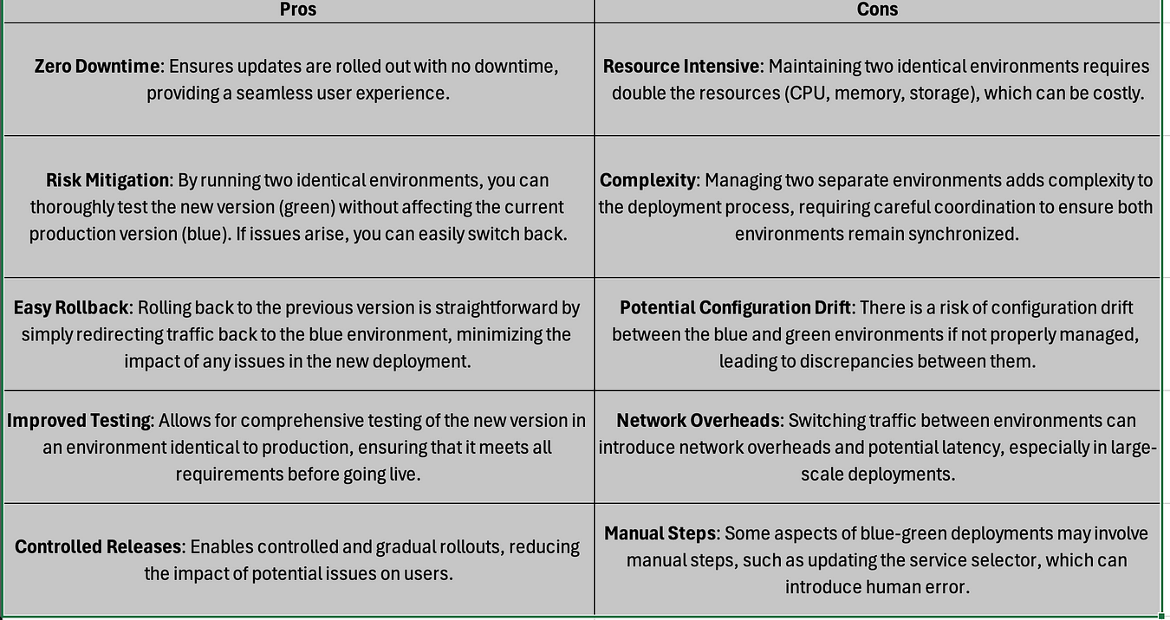

**🤝 Engage and Reflect:**

Understanding and implementing blue-green deployments is crucial for ensuring zero-downtime updates and minimizing risk during application deployments.

💬 Engage With Us: How do you plan to implement blue-green deployments in your Kubernetes projects? What challenges did you face while setting them up? Share your experiences and thoughts.

👉 Stay tuned for more learning opportunities and keep refining your Kubernetes knowledge to stay ahead in the ever-evolving tech landscape. Let’s continue to explore, innovate, and automate!